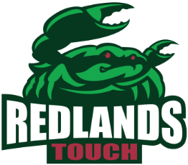New Junior Player Information Season 2 2021
Official use only:
TEAM: _________________ DIV: _______
Name: _ _ _ _ _ _ _ _ _ _ _ _ __ _ _ _ _ _ _ _ _
Address: _ _ _ _ _ _ _ _ _ _ _ _ _ _ _ _ _ _ _ _ _ _ _ _ _
Date of Birth: _ _/_ _/_ _ Gender: Male / Female
Previous Experience: _ _ _ _ _ _ _ _ _ _ _ _ _ _ _ _ _ _
Friends/School: _ _ _ _ _ _ _ _ _ _ _ _ _ _ _ _ _ _ _ _
Shirt Size: _ _ _ _
Parent or Guardian: _ _ _ _ _ _ _ _ _ _ _ _ _ _ _ _ _ _
Mobile: _ _ _ _ _ _ _ _ _ _
Email: _ _ _ _ _ _ _ _ _ _ _ _ _ _ _ _ _ _ _ _ _ _ _ _ _ _
We are looking for Coaches& Managers for each team. Could you please help out with 1 of these roles for your child’s team? TICK HERE Coach
Manager
HOW DID YOU HEAR ABOUT REDLANDS JUNIOR TOUCH? _ _ _ _ _ _ _ _ _ _ _ _
Parent or Guardian _ _ _ _ _ _ _ _ _ _ _ _ _ _ _ _ _ _ _
Signature _ _ _ _ _ _ _ _ _ _ _ _ _ _ _ _ _ _ _
Please return via email to: Mark Jansson (Operations Manager)
0413003350
admin@redlandstouch.com.au

